# Capstone Project Concept Note and Implementation Plan

## Project Title: Crop Care

## Concept Note

### Project Overview

"Crop Care: A Real-Time Crop Disease Detection System" is designed to tackle the challenge of crop diseases that threaten agricultural productivity and food security. Using the YOLO model, this project provides farmers with a tool for early disease detection and management via a user-friendly web application.

**Relevance to SDGs**

* SDG 2: Zero Hunger: Boosts food security and sustainable agriculture.
* SDG 3: Good Health and Well-being: Ensures quality food, reducing malnutrition.
* SDG 13: Climate Action: Aids in climate adaptation with weather forecasts.

**Problem Statement**

Farmers face delays in detecting crop diseases, causing significant crop losses.

**Potential Impact**

* Early Detection: Quick disease identification and management.
* Increased Yields: Healthier crops and higher productivity.
* Economic Benefits: Lower crop losses and better farmer income.
* Sustainability: Encourages sustainable farming practices.

### Objectives:

**Develop a User-Friendly Web Application:**

* Create an intuitive interface for farmers to upload crop images for disease detection.
* Ensure accessibility on various devices.

**Implement Real-Time Disease Detection:**

* Use the YOLO model to accurately identify and classify crop diseases from images.
* Provide instant feedback on detected diseases.

**Integrate Weather Forecasting:**

* Incorporate real-time weather data to offer contextual advice on disease management.
* Predict environmental conditions affecting crop health.

**Provide Treatment Recommendations:**

* Suggest appropriate treatments and preventive measures based on detected diseases.
* Use the ChatGPT API for customized recommendations and reports.

### Background

#### Contextualizing the Problem

Crop diseases pose a significant threat to agricultural productivity and food security globally. Farmers often struggle with timely and accurate detection of these diseases, which leads to substantial crop losses and economic strain. Traditional methods of disease detection are labor-intensive, time-consuming, and often lack accuracy.

#### Existing Solutions and Initiatives

Various solutions have been developed to address crop disease detection, including:

* Manual Inspections: These are time-consuming and prone to human error.
* Mobile Apps: Some apps allow farmers to capture images of crops for disease diagnosis, but their accuracy and real-time capabilities are limited.
* IoT Devices: Used for monitoring environmental conditions, but they do not directly address disease detection from images.

#### Why a Machine Learning Approach is Necessary

Machine learning, particularly deep learning, offers significant advantages for crop disease detection:

* High Accuracy: Models like YOLO can process and analyze images with high precision.
* Real-Time Detection: Machine learning models can provide instant feedback, enabling timely intervention.
* Scalability: Once trained, these models can handle large volumes of data, making them suitable for widespread use.
* Comprehensive Analysis: Integrating weather forecasting and treatment recommendations provides a holistic approach to managing crop health.

### Methodology

The project leverages state-of-the-art machine learning techniques to enable real-time crop disease detection and management.

Key Algorithms, Models, and Frameworks

#### YOLO v8 (You Only Look Once) Model:

* Purpose: Real-time object detection and classification.
* Role: Accurately identifies and classifies crop diseases from images in real-time.

#### Streamlit:

* Purpose: Developing the web application interface.
* Role: Provides an intuitive and interactive user interface for farmers to upload images and receive instant feedback.

#### OpenWeatherMap API:

* Purpose: Integrating real-time weather forecasting.
* Role: Provides weather data to offer contextual advice on disease management and predict environmental conditions affecting crop health.

#### ChatGPT API:

* Purpose: Generating treatment recommendations.
* Role: Offers customized suggestions and reports based on detected diseases and weather conditions.

These methodologies and tools ensure a robust and efficient system for early disease detection, comprehensive crop management, and enhanced agricultural productivity.

### Architecture Design Diagram

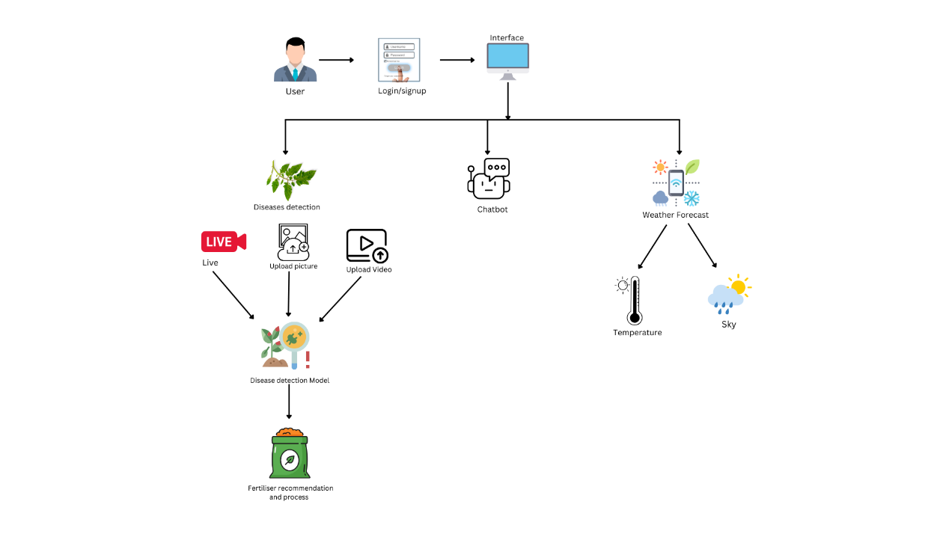

## Data Sources: The primary data source for this project is Roboflow, which provides annotated datasets of high-resolution images of crops affected by various diseases. These images are crucial for training and validating the YOLO v8 model to ensure accurate and real-time disease detection. The dataset includes different types of crop diseases, providing a comprehensive basis for the model to learn diverse disease patterns. Preprocessing steps involve resizing images to a standard resolution, normalizing pixel values, and augmenting the data through techniques like rotation, flipping, and contrast adjustments to enhance model robustness and performance. This preprocessing ensures that the model can generalize well to new, unseen data, thereby improving its accuracy and reliability in real-world applications.

### Literature Review

The methodology and approach for this project are supported by existing research that demonstrates the effectiveness of machine learning models, particularly YOLO, in agricultural applications. For instance, Mohanty et al. (2016) showed that deep learning models could achieve high accuracy in detecting plant diseases from images. Similarly, Sladojevic et al. (2016) emphasized the potential of convolutional neural networks for plant disease recognition, which aligns with our use of YOLO v8 for real-time detection. Additionally, integrating weather data for predictive modeling, as explored by Peterson et al. (2018), underpins our project's incorporation of real-time weather forecasting to enhance disease management recommendations. This project builds upon these foundations by employing the latest YOLO v8 model for enhanced real-time performance and integrating advanced APIs like OpenWeatherMap and ChatGPT to provide comprehensive, actionable insights for farmers.

## Implementation Plan

### Technology Stack

**Technologies and Tools**

**Programming Languages:** Python

**Libraries:**

* PyTorch: For model development and training.
* OpenCV: For image preprocessing and augmentation.
* Streamlit: For developing the web application interface.
* Requests: For API calls to OpenWeatherMap and ChatGPT.

**Frameworks:**

* YOLO v8: For real-time object detection and classification.

**APIs:**

* OpenWeatherMap API: For integrating real-time weather data.
* ChatGPT API: For generating treatment recommendations.

**Software:**

* Roboflow: For accessing and managing annotated image datasets.

**Hardware:**

* High-performance computer with GPU for model training.
* Smartphones or cameras for capturing crop images.

### Timeline

|  |  |  |
| --- | --- | --- |
| Stage | Tasks | Deadline |
| Data Collection and Preprocessing | Collecting images from Roboflow, preprocessing (resizing, normalizing, augmenting) | Week 1 - Week 2 |
| Model Development | Implementing YOLO v8 for disease detection | Week 3 - Week 4 |
| Training and Evaluation | Training the model, evaluating accuracy, precision, recall | Week 5 - Week 6 |
| Deployment | Developing Streamlit app, integrating APIs, deploying web app | Week 7 - Week 8 |

### Milestones

|  |  |  |
| --- | --- | --- |
| Milestone | Description | Deadline |
| 1 | Completion of data collection and preprocessing | End of Week 2 |
| 2 | Initial implementation of YOLO v8 model | End of Week 4 |
| 3 | Successful training and evaluation of the model | End of Week 6 |
| 4 | Deployment of web application | End of Week 8 |

### Challenges and Mitigations

**Anticipated Challenges and Mitigations**

* Data Quality: Ensuring high-quality, annotated data for training.
* Mitigation: Use Roboflow’s high-quality datasets and apply rigorous preprocessing steps.
* Model Performance: Achieving high accuracy and real-time performance.
* Mitigation: Optimize the YOLO v8 model and perform extensive hyperparameter tuning.
* Technical Constraints: Managing computational resources for training large models.
* Mitigation: Use a high-performance computer with a GPU and leverage cloud-based resources if necessary.

### Ethical Considerations

**Ethical Considerations**

* Data Privacy: Ensuring that any data collected from users is stored securely and used only for the intended purposes.
* Strategy: Implement robust data encryption and secure storage solutions.
* Bias: Addressing potential biases in the training data that could affect model performance.
* Strategy: Use diverse datasets and perform bias analysis to ensure the model is fair and unbiased.
* Impact on Target Community: Ensuring that the tool benefits farmers without causing undue reliance on technology or displacement of traditional practices.
* Strategy: Provide clear guidance on integrating the tool with existing practices and offer support for technology adoption.

By addressing these key areas, the project aims to deliver a robust, ethical, and impactful solution for real-time crop disease detection and management.